GIT CHALLENGE

**1.Resolve Merge Conflicts**

*created 2 branches with similar contents in it

*merge 2 those branches

*conflicts arrives

*master branch = good morning

*release branch = good evening

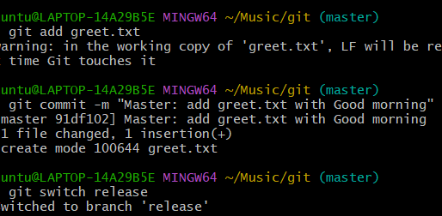

*merge the 2 branches conflict arrives

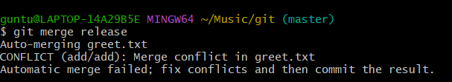

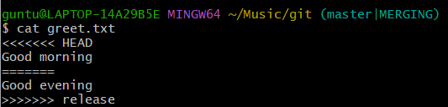

*git add .

*git commit – “merge conflict resolved”

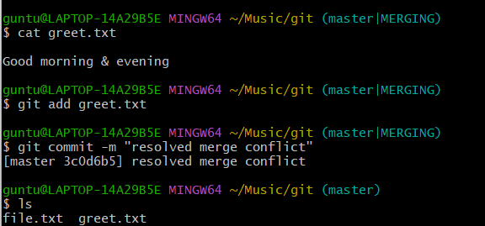

2. **Recover Deleted Branch**

**\***delete existing branch commad = git branch -D hotfix

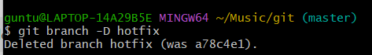

*check commit id

*command= git reflog

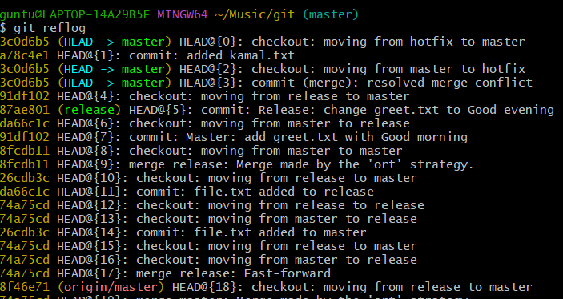

*copy the commit id of hotfix

*now to retrive the branch

*git branch hotfix (commitid)

*to verify git switch hotfix

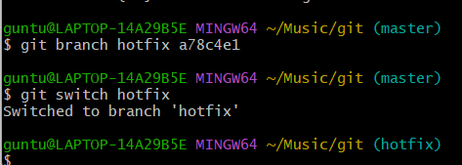

3. **Undo Wrong Push**

**\***git add .

*git commit -m “added to master”

*git push

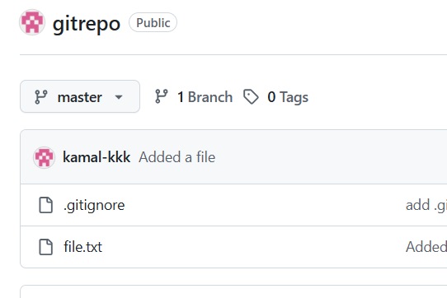

*git log for commit id

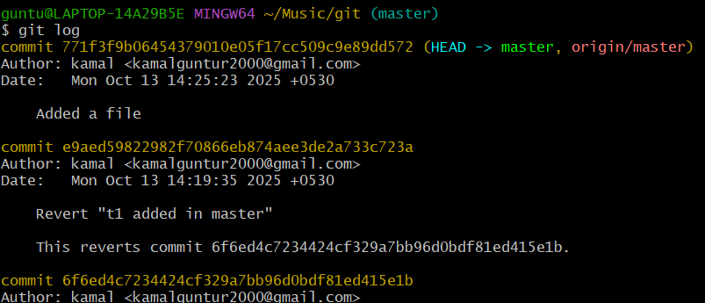

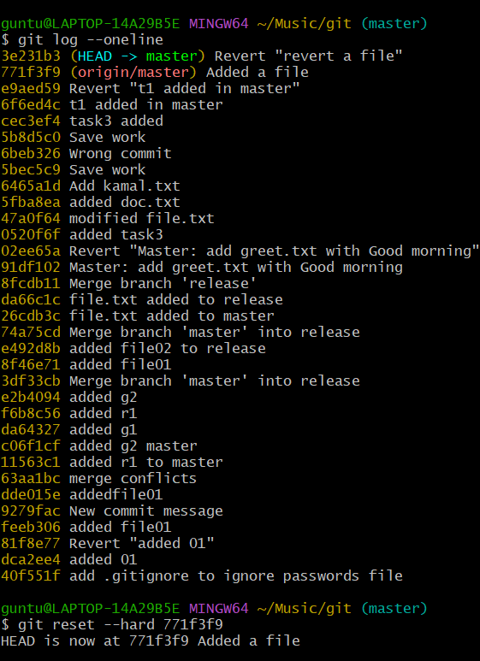

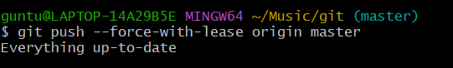

4. **Amend a Commit**

* + Make a commit, then add a missing file to it using git commit --amend.

*Created a file a

*Git add.

*git commit -m

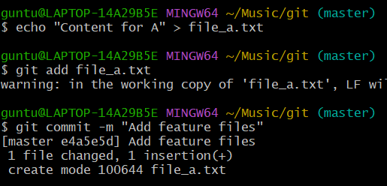

*amend

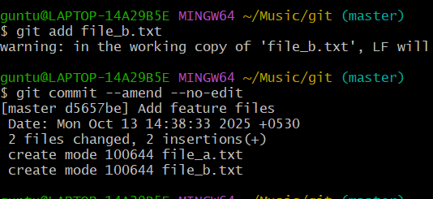

*to verify git log -1

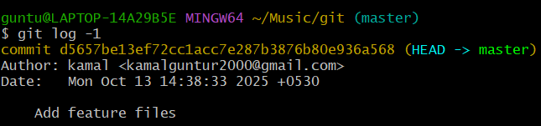

5. **Cherry-pick a Commit**

* Take a specific commit from one branch and apply it to another branch

*Create one file in 2 different branch

*we different commit ids

*git log feature-branch –oneline

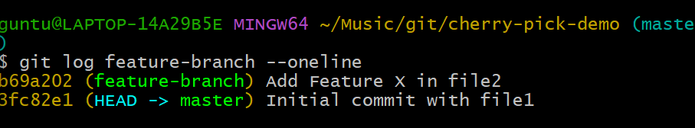

*git cherry pick and commit id

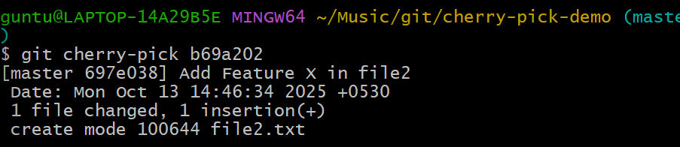

6. **Interactive Rebase**

Reorder and squash multiple commits into a single clean commit.

*create 3 files

*Add 1 line

*git log –oneline

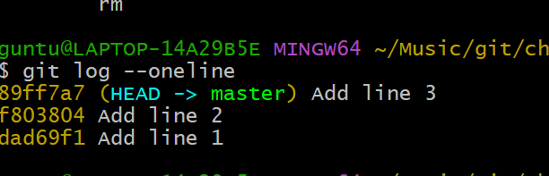7. **Tagging & Release**

Create a version tag (v1.0), push it to GitHub, then delete and restore it.

*create version tag

* git tag -a v1.0 -m "Release version 1.0"

*verify git tag

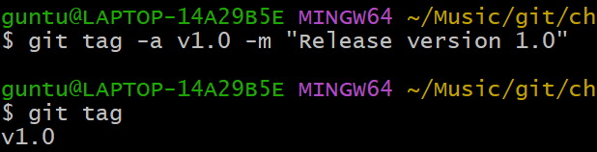

*git push origin v1.0

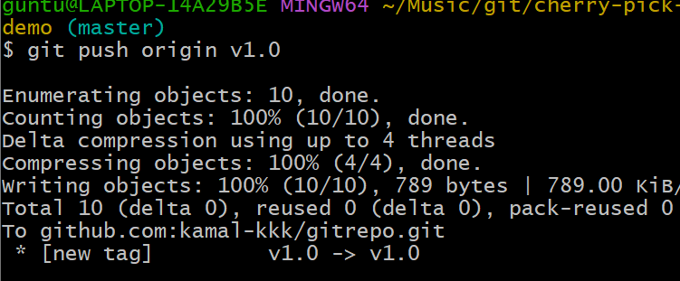

*then delete it

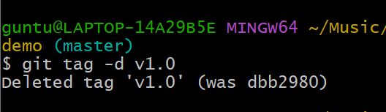

*to restore

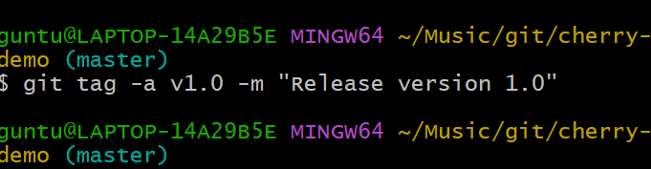

*verify git push origin v2.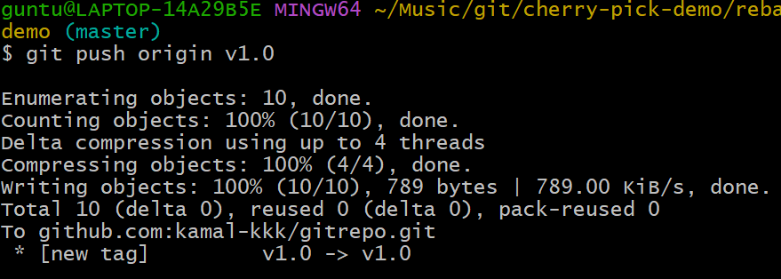0

8. **Clone with Sparse Checkout**

Clone only a subdirectory of a repo using sparse checkout

* git clone --no-checkout git@github.com:kamal-kkk/gitrepo.git myrepo

cd myrepo

* git sparse-checkout init –cone

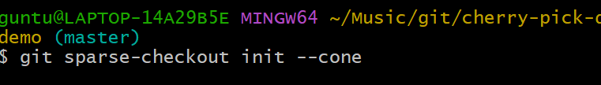

*select the subdirectory

Git sparse-checkout set src

*ls to verify

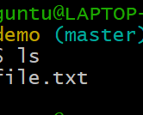

9. **Reset vs Revert Challenge**

Demonstrate the difference between git reset --hard and git revert in a repo.

*create a repo reset nd revert

*get init

*created commit ids b files

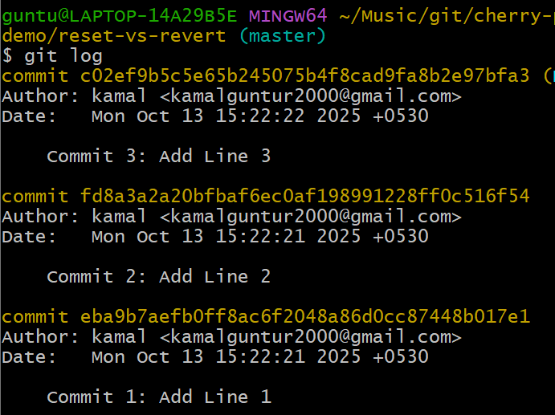

*git log –oneline

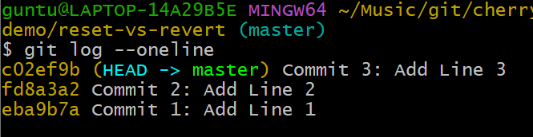

10. **Detached HEAD Challenge**

Checkout a specific commit (detached HEAD state) and create a new branch from it.

*create a file

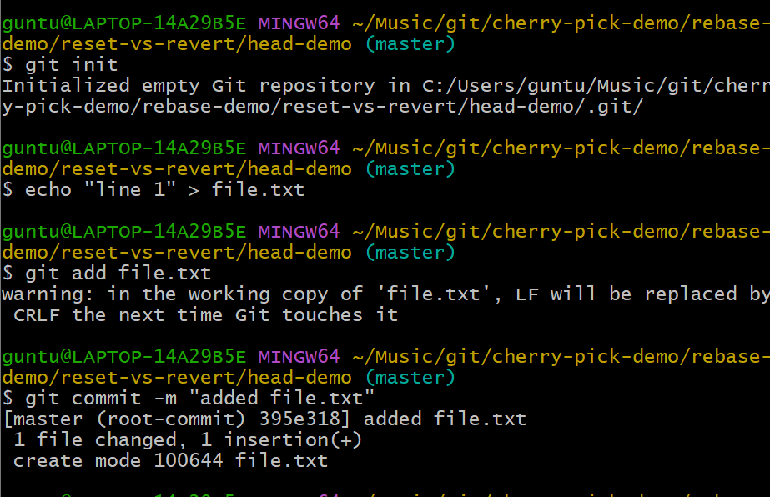

*git log –oneline for commit ids

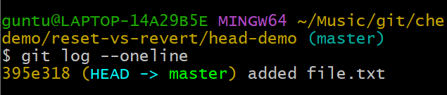

*git checkout head

*git checkout (commit id)

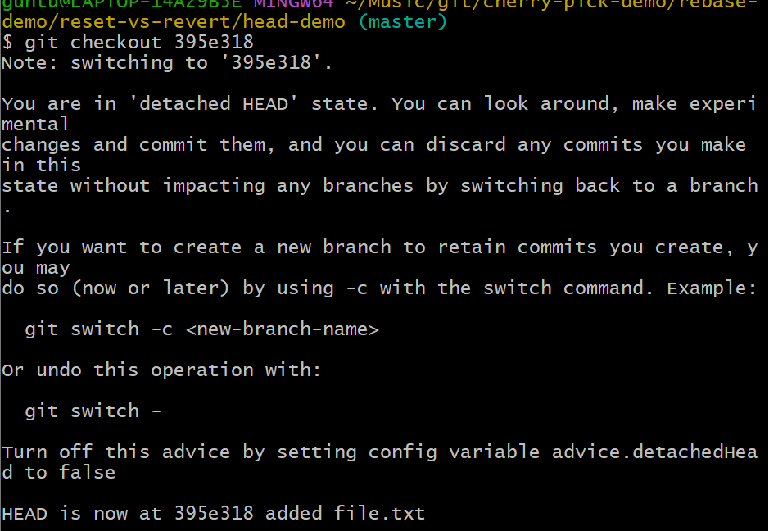

*to verify

Git checkout (commit id)  
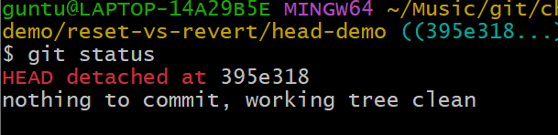

11. **Git Hooks Challenge**

*create commit-msg

*vi commit

*add script

#!/bin/bash

# Get the commit message

commit_msg=$(cat "$1")

# Regex to check for JIRA ticket at the start

pattern="^JIRA-[0-9]+:"

if ! [[ "$commit_msg" =~ $pattern ]]; then

echo "ERROR: Commit message must start with JIRA-XXX:"

echo "Example: JIRA-101: Add new feature"

exit 1 # Exit with non-zero to reject commit

fi

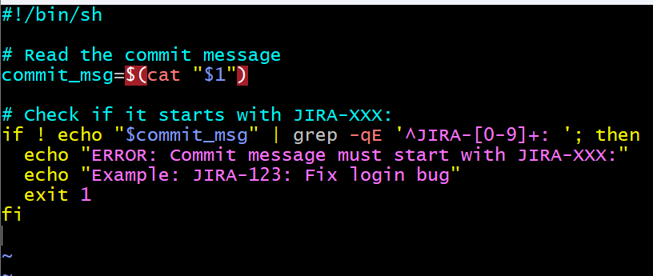

*

Git commit -m “JIRA-123: fix some bug”

*this will pass

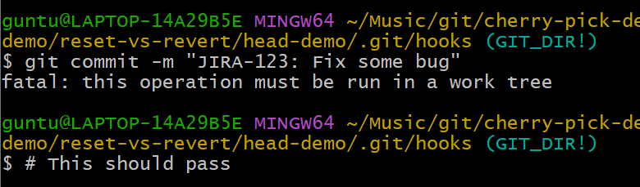

12. **Squash Merge vs Rebase Merge**

**\***created branch master and release

*master branch has 1 file

*release branch has 3 files

*all the files are in tracking zone and committed

*to squash merge

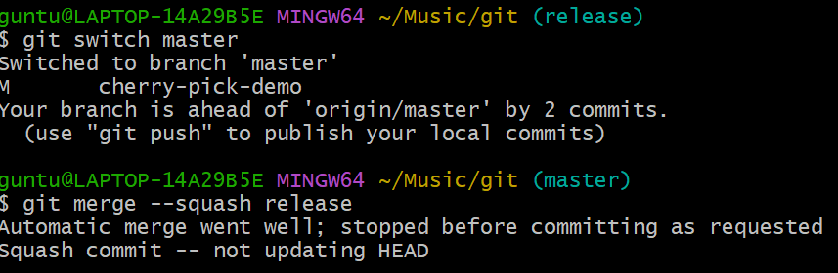

*switch to master branch

*Git merge –squahs merge release

*git commit -m “add multiple line”

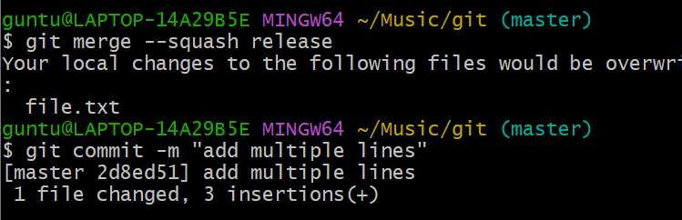

*to verify git log –oneline

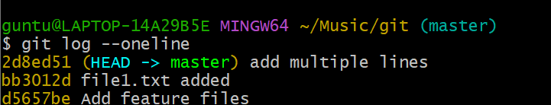

REBASE MERGE

*switch to release

*git rebase master

*now switch to master

*git rebase release

*git merge release

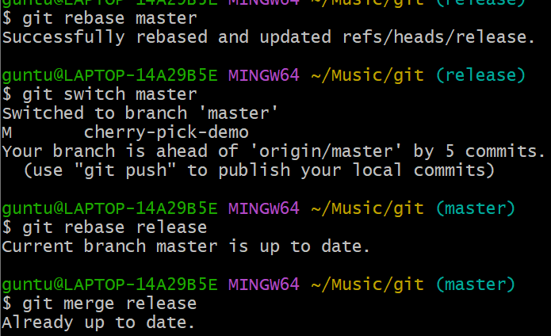

*to verify git log –oneline

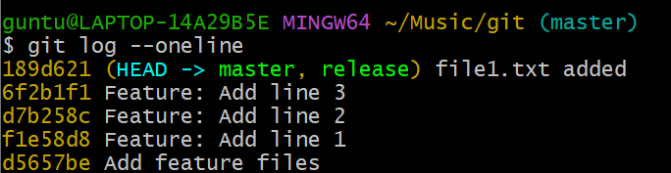

13. **Fork & Pull Request Workflow**

Fork a repo, make a change, and submit a pull request to the original repo.

*

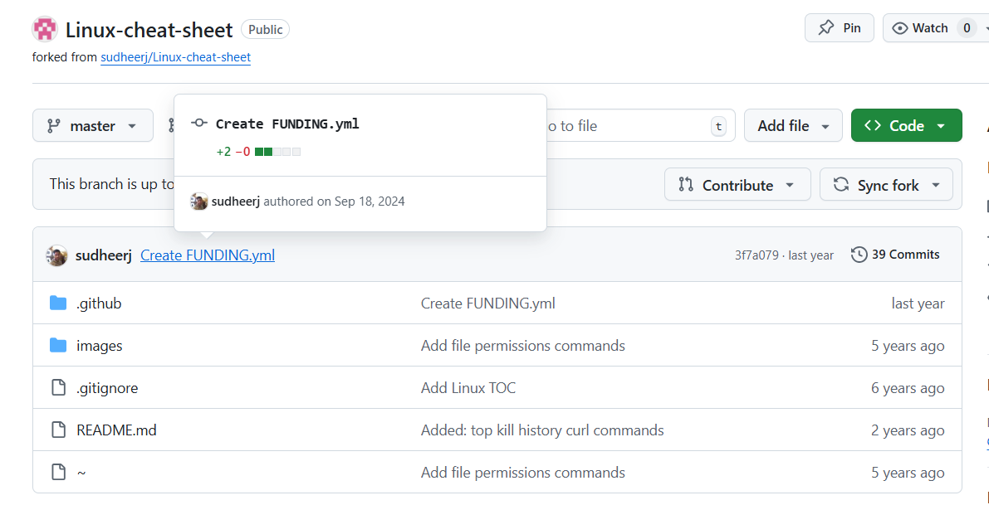

*cloning

*git clone [git@github.com:kamal-kkk/Linux-cheat-sheet.git](mailto:git@github.com:kamal-kkk/Linux-cheat-sheet.git)

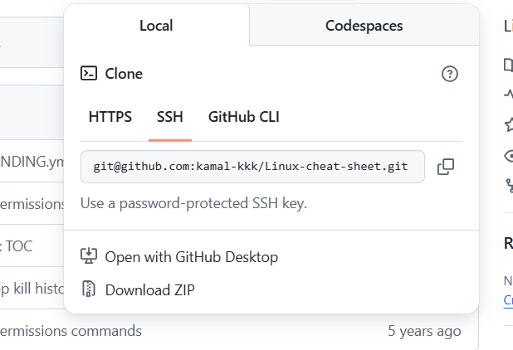

*command- git clone [git@github.com:kamal-kkk/Linux-cheat-sheet.git](mailto:git@github.com:kamal-kkk/Linux-cheat-sheet.git)

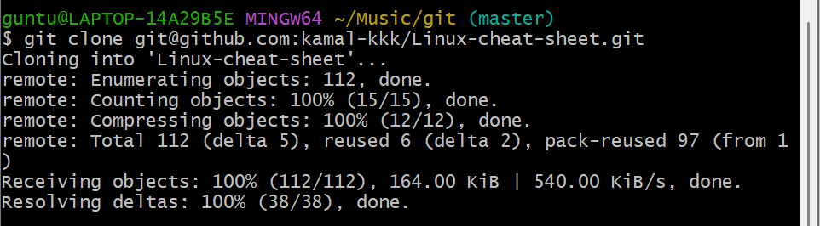

*created new branch called fork

*git add . in tracking zone and committed

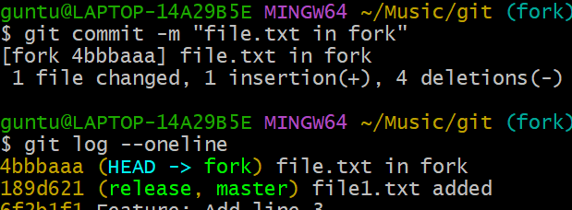

*git push origin fork

*git branch -r

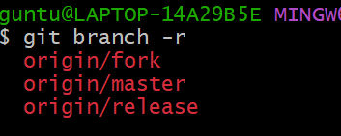

*pull request

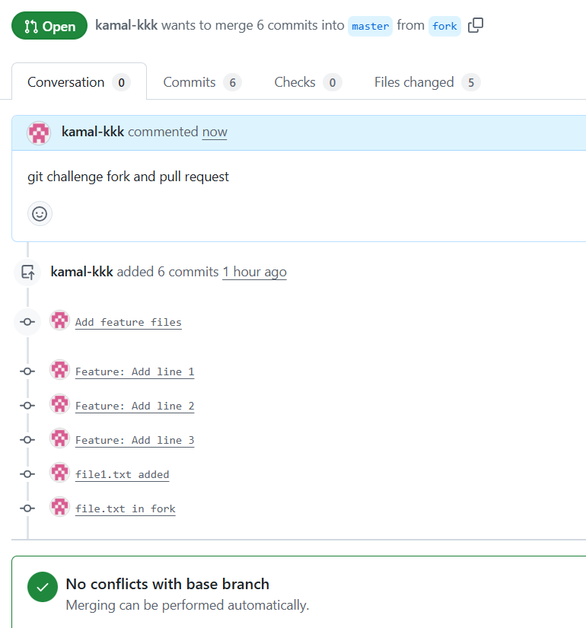

14. **Recover Lost Commit**

Commit something, reset hard, and then recover it using git reflog.

*git log –oneline

*choose the commit id

*Git reset --hard 6f2b1f1

*git reflog

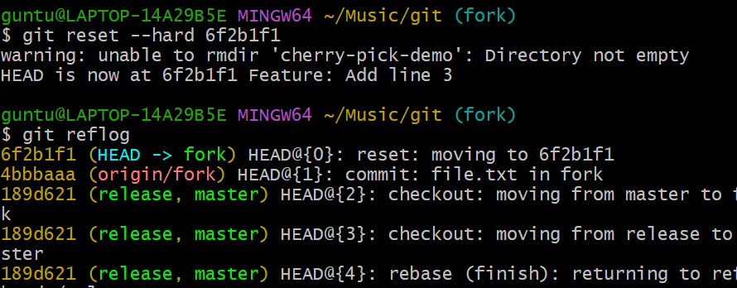

*git switch 6fb1f1

*restore permanently git reset –hard 6fb1f1

*git log –oneline

*to verify

